1. In the next few steps, we will want to play with
   1. API Gateways,
   2. Distributed Tracking,
   3. Circuit Breaker
2. So, we need a couple of more microservices.
3. 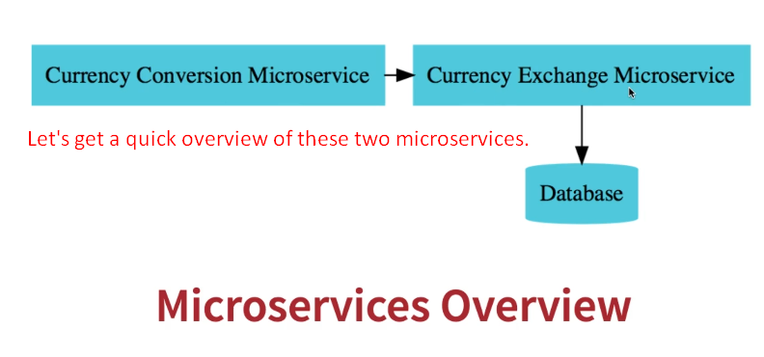
4. 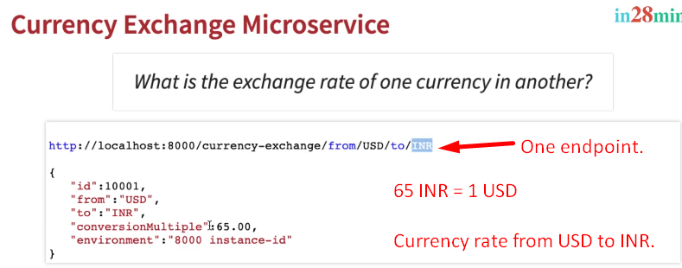
5. 